Analysing the Alignment Between Corporate Social Responsibility Disclosures and Public Opinion Using Big Data Analytics.

CSCT Master Project
MSc Data Science
Name | Kevan Muthomi Ndwiga
Student ID | 25003723
Supervisor | Dr Hemlata Sharma
Faculty | College of Arts, Technology, and Environment
Department | School of Computing and Creative Technologies
University | University of the West of England, Bristol.

Date of Submission: [8th January 2026]
Word Count: [Total Word Count 6556 excluding appendices and references]

Declaration
I declare that the work in this dissertation is my own, except where indicated by proper referencing. This work has not been submitted for any other academic qualification at any other institution.

Abstract
Corporate Social Responsibility (CSR) disclosures are increasingly used by firms to signal ethical conduct and sustainability commitments. However, whether such disclosures align with public perception remains an open empirical question. This study investigates the alignment between corporate CSR disclosures and public sentiment by integrating structured ESG performance data with unstructured sentiment data derived from online public discourse.
The research adopts a mixed-method analytical approach combining exploratory data analysis, regression modelling, classification techniques, and interactive visual analytics. Sentiment data were transformed to address distributional skewness, enabling robust statistical modelling. Ordinary Least Squares regression was used to examine the relationship between ESG scores and sentiment, while logistic regression–based classification models were employed to predict ESG performance and CSR–sentiment alignment. Model performance was evaluated using accuracy, precision, recall, and ROC-AUC metrics.
Findings indicate a statistically significant but weak relationship between public sentiment and ESG scores, suggesting that sentiment alone is insufficient for strong predictive modelling. Nevertheless, sentiment signals proved valuable in identifying cases of alignment, particularly when explored through visual analytics. To translate analytical insights into actionable intelligence, the study developed an interactive Tableau dashboard that visualizes alignment patterns across companies, ESG pillars, and industry sectors.
The project contributes methodologically by demonstrating an integrated framework for CSR alignment analysis and practically by delivering a prototype decision-support dashboard. The findings offer evidence-based insights to support more transparent and responsive CSR communication strategies.

Table of Contents

Abstract ii
Table of Contents iii
List of Figures vi
Chapter 1: Introduction 1
1.1 Context of the Project 1
1.2 Rationale for the Study 2
1.3 Problem Statement and Scope 2
1.4 Research Aim and Objectives 4
Research Aim 4
Research Objectives 4
1.5 Significance of the Study 4
1.6 Structure of the Dissertation 5
Chapter 2: Literature Review 6
2.1 Evolution of Corporate Social Responsibility and ESG Disclosure 6
2.2 Determinants and Quality of CSR Disclosures 6
2.3 Public Perception and Social Media Sentiment 6
2.4 Greenwashing and CSR Misalignment 7
2.5 Big Data and Machine Learning in CSR Analysis 8
2.6 Research Gap and Contribution 8
Chapter 3: Proposed Artefact 9
3.1 Introduction and Justification of Artefact Choice 9
3.2 Artefact Overview 10
3.2.1 ESG vs Reddit Sentiment Scatter Plot 10
3.2.2 ESG Pillar Comparison 10
3.2.3 CSR-Sentiment Alignment Indicators 11
3.2.4 Sector-Level Heatmaps 11
3.3 Artefact Objectives 12
3.4 Relationship Between the Artefact and Research Aims 12
Chapter 4: Methodology 14
4.1 Research Design and Approach 14
4.2 Data Sources and Collection 15
4.2.1 CSR Disclosure Data 15
4.2.2 Public Perception Data (Reddit) 15
4.3 Tools, Technologies and Analytical Environment 16
4.4 Data Preprocessing and Integration 16
4.4.1 Data Cleaning and Harmonization 16
4.4.2 Feature Engineering 17
4.5 Exploratory Data Analysis 17
4.6 Statistical Modelling and Transformations 18
4.6.1 Regression Framework 18
4.6.2 Addressing Skewness through Transformations 18
4.7 Classification and Alignment Modelling 19
4.8 Dashboard Development (Design Science Component) 19
4.9 Ethical Considerations 20
4.10 Methodological Limitations 20
4.11 Chapter Summary 20
Chapter 5: Results and Evaluation. 22
5.1 Artefact Results 22
5.1.1 Exploratory Relationship Between ESG Performance and Public Sentiment 23
5.1.2 Pillar-Level ESG Comparisons 24
5.1.3 Sentiment Intensity Across ESG Quartiles 25
5.1.4 CSR-Sentiment Alignment Patterns 26
5.1.5 Sector-Level Misalignment 27
5.2 Model Results 28
5.2.1 Regression Results 28
5.2.2 Classification Model Results: ESG Performance 29
5.2.3 Classification Model Results: CSR-Sentiment Alignment 30
5.3 Artefact Evaluation. 32
5.3.1 Dashboard Usability 32
5.3.2 Interpretability. 32
5.3.3 Alignment with User Needs. 32
5.4 Model and Analytical Evaluation 33
5.4.1 Regression Diagnostics 33
5.4.2 Classification Metrics 33
5.5 Evaluation of Overall Approach 35
Chapter 6: Conclusion 36
6.1 Summary of the Project 36
6.2 Summary of Results 36
6.3 Achievement of Aims and Objectives 37
6.4 Extent to Which the Problem Was Addressed 37
6.5 Future Work 37
Bibliography 38
Appendices 38
Record of Meetings with Supervisor 38
Ethical Approval Form 38
GitHub Repository Link 38
References 39

List of Figures

Figure 1: Scatter plot illustrating the relationship between total ESG scores and average public sentiment across firms. The dispersion highlights instances of CSR–sentiment alignment and misalignment, underscoring the complexity of stakeholder perception. 22
Figure 2: Comparison of Environmental, Social, and Governance pillar scores across firms, highlighting internal imbalances within CSR performance. 23
Figure 3: Distribution of public sentiment across ESG quartiles, illustrating substantial overlap and indicating that ESG performance alone does not determine public perception. 24
Figure 4: Distribution of aligned and misaligned firms based on relative ESG and sentiment thresholds, demonstrating the prevalence of CSR–sentiment misalignment. 25
Figure 5: Aligned Sectors 26
Figure 6: Misaligned Sectors 27
Figure 7: OLS regression illustrating the non-linear relationship between squared sentiment and total ESG score, indicating statistically significant but limited explanatory power. 28
Figure 8: Confusion matrix for logistic regression predicting high versus low ESG performance, demonstrating modest classification accuracy. 29
Figure 9:Confusion matrix for logistic regression predicting CSR–sentiment alignment, highlighting high recall for aligned firms. 30

Chapter 1: Introduction

Context of the Project
Corporate Social Responsibility (CSR) has grown from a side concern to a key part of modern business plans. Today's markets expect companies to do more than just make profits. They demand firms to include social, environmental, and governance issues in their main work. In recent years, there has been a significant increase in companies sharing information regarding their sustainability and Environmental, Social and Governance (ESG) efforts. This comes from stakeholder scrutiny, regulatory pressures, and transparency in corporate conduct (Bosi et al. 2022).
Companies now publish detailed CSR and ESG reports to demonstrate accountability and transparency. These reports articulate their commitments to sustainability, employee welfare, ethical governance, and community engagement. These reports serve as key ways to communicate company values, manage reputational risk, and enhance their legitimacy with investors, consumers, regulators, and the general public (Michelon, Pilonato and Ricceri 2015; Bosi et al. 2022)
However, the effectiveness of CSR and ESG disclosures depends not only on what organizations report, but also in how the disclosures are perceived. In the digital age, public perception is increasingly shaped through social media platforms, online forums, and news outlets, where stakeholders actively express opinions, critique corporate behaviour, and challenge perceived inconsistencies. Platforms such as Reddit have become influential spaces for stakeholder “voice”, offering real-time, unsolicited, and often emotionally charged reactions to corporate actions (Mamo & Anagnostopoulos, 2023).

Rationale for the Study
Existing CSR research has predominantly examined disclosure practices and public perception as separate analytical domains. Disclosure-focused studies typically asses report quality, compliance, or ESG performance metrics, while perception-based studies often analyse social media sentiment or reputational outcomes independently (Kolk, 2016).

Recent advances in big data analytics and machine learning offer new opportunities to empirically investigate this alignment. By integrating structured CSR disclosure data with unstructured public opinion data at scale, researchers can move beyond anecdotal evidence and develop systematic, data-driven assessments of CSR effectiveness (Barbeito- Caamaño & Chalmeta, 2020). This project situates itself at the intersection of CSR research, sentiment analysis, and data-driven decision support systems.
This project is motivated by three keys gaps:
- The lack of integrated CSR-sentiment alignment frameworks.
- Limited use of social media data to validate CSR disclosures quantitatively.
- A scarcity of interactive artefacts that translate CSR analytics into actionable insights.

Problem Statement and Scope
Despite increased CSR disclosure requirements, organizations often struggle to ensure that sustainability narratives resonate with stakeholder perceptions.
This dynamic has given rise to the critical question:
Do CSR disclosures genuinely align with public perception, or do they merely represent symbolic communication detached from stakeholder sentiment?

While organizations increasingly adopt structured ESG reporting frameworks, the credibility and perceived authenticity of such disclosures remain contested, particularly when public sentiment diverges from corporate narratives (Delmas and Burbano, 2011). Misalignment between reported CSR performance and public opinion can undermine organizational credibility, fuel accusations of greenwashing, and erode stakeholder trust (Yu, Luu & Chen, 2020).

Despite the proliferation of CSR disclosures, there remains a persistent gap between corporate self-representation and stakeholder perception. While organisations invest substantial resources in sustainability reporting, stakeholders frequently express scepticism regarding the authenticity, depth, and impact of these initiatives. This scepticism is amplified in online environments, where perceived inconsistencies between corporate claims and observed practices are rapidly disseminated and scrutinised (Borland et al., 2018).

The challenge is compounded by the fact that traditional CSR evaluation methods rely heavily on self-reported metrics and third-party ratings, which may not adequately capture public sentiment or evolving stakeholder expectations. Consequently, organizations may remain unaware of misalignments between their disclosed CSR performance and public opinion until reputational damage has already occurred.

From an academic perspective, existing CSR research has largely treated disclosure quality and stakeholder perception as distinct domains. While a growing body of literature has explored public sentiment and social media reactions to corporate sustainability initiatives, these studies often focus on isolated events or communication strategies rather than systematically integrating large-scale CSR disclosure data with public sentiment analytics. Consequently, empirical research that jointly evaluates the alignment between formal CSR reporting and aggregated public perception remains limited, particularly at scale (Michelon, Pilonato and Ricceri, 2015; Saxton, Gomez and Ngoh, 2019; Cuesta-Valiño, P. et al. 2024).

The scope of the study is defined as follows:
- Focus on largely public listed companies (S&P 500 constituents).
- CSR data sourced from publicly available reports.
- Public perception measured via Reddit sentiment.
- Quantitative analysis supported by an interactive dashboard artefact.

Research Aim and Objectives

Research Aim
To evaluate the alignment between corporate social responsibility disclosures and public perception using data-driven analytical methods and interactive visualization

Research Objectives
- To gather and preprocess CSR disclosure data from selected companies and corresponding opinion data from social media platforms (Reddit).
- To employ big data analytics and machine learning techniques to identify patterns and measure alignment between CSR disclosures and public sentiment.
- To design and develop a prototype dashboard that reflects alignment or misalignment in an interpretable manner.
- To offer evidence-based recommendations for improving CSR communication strategies.

Significance of the Study
This research contributes to both academic and practical domains. Academically, it extends CSR literature by integrating disclosure analysis with social media sentiment at scale. Practically, it provides organizations and stakeholders with a decision-support artefact capable of highlighting communication gaps and reputational risks.

Structure of the Dissertation
The remainder of this dissertation is structured as follows:
- Chapter 2 reviews relevant literature on CSR disclosure, public perception, sentiment analysis, and alignment frameworks.
- Chapter 3 introduces the proposed artefact and its relationship to the research aims.
- Chapter 4 details the methodology adopted.
- Chapter 5 evaluates the artefact and analytical approach.
- Chapter 6 concludes the study and outlines future research directions.

Chapter 2: Literature Review

2.1 Evolution of Corporate Social Responsibility and ESG Disclosure
The academic literature identifies CSR and ESG reporting as an evolving mechanism through which firms seek legitimacy and stakeholder approval. Bosi et al. (2022) demonstrate that ESG disclosures have transitioned from voluntary narrative statements to more formalised, metric-driven reporting systems. However, stakeholder theory suggests that disclosure alone does not guarantee legitimacy; alignment with public perception is critical (Awa, H. O. et al. 2024). When discrepancies arise between corporate disclosures and societal sentiment, firms risk reputational damage and accusations of compliance or greenwashing (Delmas and Burbano, 2011).

2.2 Determinants and Quality of CSR Disclosures
Research on CSR disclosure has extensively examined the determinants of corporate reporting practices, with particular attention o regulatory frameworks, firm size, industry affiliation, and governance structures. Prior studies consistently demonstrate that firms operating in more stringent regulatory environments and those with stronger governance mechanisms tend to exhibit higher levels of CSR disclosure (Dilla, W. et al., 2016; Ioannou & Serafeim, 2011). Furthermore, cross-country analyses indicate that institutional context-such as legal systems, enforcement quality, and stakeholder expectations-plays a critical role in shaping the transparency and credibility of CSR reporting, leading to substantial variation in disclosure practices across different economic and institutional settings (Kolk, 2016).

2.3 Public Perception and Social Media Sentiment
Public perception has increasingly been shaped by digital platforms, where social media and online forums act as real-time platforms for stakeholder evaluation of corporate behaviour. Prior research indicates that sentiment expressed on platforms such as Reddit can serve as a proxy for broader societal attitudes toward corporate social responsibility (Khan, M. et al. 2016). Consequently, comparing ESG disclosures with public sentiment enables a more nuanced assessment of whether firms’ sustainability narratives resonate with external stakeholders.

With the rise of digital platforms, stakeholders increasingly use social media to evaluate, endorse, or challenge corporate behaviour. Mamo and Anagnostopoulos (2023) describe social media as a powerful mechanism for stakeholder voice, enabling rapid collective responses to corporate actions.

2.4 Greenwashing and CSR Misalignment
The concept of greenwashing has gained prominence as firms face accusations of exaggerating or misrepresenting sustainability efforts. Yu, Luu and Chen (2020) argue that misalignment between disclosures and actual performance increases reputational risk and undermines long-term legitimacy.

Borland, H. et al. (2019) further highlight the “dark side” of CSR, noting that stakeholder backlash can occur when CSR initiatives are perceived as insincere or inconsistent with corporate behaviour. There findings underscore the importance of evaluating not only what firms disclose, but how those disclosures are received.

2.5 Big Data and Machine Learning in CSR Analysis
Advances in big data analytics have enabled researchers to integrate diverse data sources and analyse CSR at scale. Barbeito- Caamaño and Chalmeta (2020) demonstrate how big data can enhance CSR evaluation by incorporating real-time, external data streams.

More recently, Ujjwal, D. et al. (2023) emphasize the potential of machine learning techniques to uncover latent patterns in CSR and sentiment data, while also cautioning against ethical and methodological challenges associated with large-scale data integration.

2.6 Research Gap and Contribution
While prior studies have examined CSR disclosures and social media sentiment independently, there remains a gap in integrated, data-driven assessments of alignment between the two. Moreover, few studies translate analytical findings into practical tools that support ongoing monitoring and decision-making.

This research addressed these gaps by combining CSR disclosure data with public sentiment data using machine techniques and presenting the results through an interactive dashboard. In doing so, it bridges theory and practice, offering both empirical insights and actionable outputs.

Chapter 3: Proposed Artefact
This chapter focuses on the final artefact, specifically on justification for the software used in coming up with the final artefact, the general overview and how it aligns with the intended research aims and objectives.

3.1 Introduction and Justification of Artefact Choice
This project makes use of an interactive Tableau-based analytical dashboard as the primary artefact for evaluating the alignment between CSR disclosures and Reddit sentiments. Tableau was selected in preference to alternative visualization tools such as Power BI, Excel Dashboards, or static Python-based plotting libraries for several methodological and practical reasons.

First, Tableau provides advanced capabilities for interactive, multi-dimensional data exploration, which is essential for analysing complex relationships between ESG performance metrics, sentiment scores and industry-level characteristics. Unlike static visualizations, Tableau allows users to dynamically filter, segment, and drill down into the data, supporting both exploratory and explanatory analysis. Second, Tableau is widely adopted in both industry and academia, enhancing the artefact’s practical relevance and transferability beyond a purely academic setting. Third, tableau supports real-time or near-real-time data integration, aligning with the project’s objective of developing a prototype capable of reflecting ongoing alignment or misalignment between corporate disclosures and public opinion.

Finally, tableau’s ability to integrate calculated fields, table calculations, and dashboard-level interactivity makes it particularly suitable for operationalizing abstract constructs-such as “CSR-Sentiment Alignment”- into intuitive visual representations. As such the dashboard serves not only as a visualization tool but also as a decision support system grounded in empirical analysis.

3.2 Artefact Overview
The proposed artefact is a multi-sheet interactive dashboard design to synthesize CSR disclosure data and Reddit based sentiment analytics for S&P 500 companies. The dashboard integrates ESG performance scores, sentiment polarity measures, post volume indicators, and sector classifications to provide a comprehensive view of how corporate CSR narratives align with public perception.
The dashboard consists several interrelated components, each addressing a specific analytical dimension of the research problem.

3.2.1 ESG vs Reddit Sentiment Scatter Plot
The primary visual element is a scatter plot mapping companies’ total ESG scores against their average Reddit sentiment scores. Each point represents an individual company, with point size reflecting the volume of Reddit posts analysed and colour encoding ESG quartiles and sector categories.
This visualization enables rapid identification of patterns, such as companies with high ESG performance but negative public sentiment (potential misalignment) or firms with modest ESG scores but favourable sentiment (potential overperformance in public communication). Interactive tooltips provide additional contextual information, including company name and post count, supporting micro-level inspection alongside macro-level analysis.

3.2.2 ESG Pillar Comparison
To disaggregate overall ESG performance, the dashboard includes a pillar comparison bar chart displaying Environmental (E), Social (S), and Governance (G) scores for selected companies. This component allows users to identify which ESG dimensions contribute most strongly to overall performance and whether specific pillars are more closely associated with public sentiment.

By enabling company-level filtering, this visualization supports comparative analysis and facilitates deeper interpretation of how different aspects of CSR disclosure may resonate differently with stakeholders.

3.2.3 CSR-Sentiment Alignment Indicators
A core contribution to the artefact is the introduction of a binary CSR-sentiment alignment indicator, classifying companies as either “Aligned” or “Misaligned.” This classification is derived from comparing a firm’s ESG score and sentiment score against distribution-based benchmarks (e.g., median or quartile thresholds).

The resulting alignment bar chart aggregates companies by alignment status, providing a high-level summary of how frequently CSR disclosures correspond with positive public perception. This component translates complex statistical relationships into a simple, interpretable metric that is accessible to non-technical stakeholders.

3.2.4 Sector-Level Heatmaps
To identify systemic patterns, the dashboard incorporates sector-based heatmaps illustrating the concentration of aligned and misaligned firms across industries. These heatmaps highlight whether certain sectors-such as energy, technology, or consumer goods-exhibit consistent discrepancies between CSR disclosures and public sentiment.

This sectoral perspective is particularly valuable for benchmarking and strategic analysis, enabling organizations to assess their performance relative to industry peers and identify sectors where CSR communication challenges may be structurally embedded.

3.3 Artefact Objectives
The proposed dashboard is designed to fulfil two primary objectives. First, it aims to translate complex analytical outputs into actionable insights by presenting sentiment analysis and ESG metrics in an integrated, intuitive format. While underlying models and statistical tests provide quantitative rigour, the dashboard ensures that results are interpretable by decision-makers without advanced data science expertise.
Second, the artefact seeks to support strategic CSR communication and evaluation. By making alignment and misalignment visually explicit, the dashboard enables firms to identify gaps between reported CSR performance and public perception, thereby informing adjustments to disclosure strategies, stakeholder engagement, and narrative farming.

3.4 Relationship Between the Artefact and Research Aims
The Tableau dashboard functions as the primary mechanism through which the aim-connecting public opinion with CSR disclosures through application of big data analytics-is operationalized, translating complex analytical outputs into an integrated and interpretable decision-support artefact.
This dashboard directly supports the integration of structured CSR disclosure data-derived from formal sustainability and ESG reports-with unstructured public opinion data obtained from Reddit. By visualizing these heterogenous data sources within a unified analytical environment, the artefact enables a comprehensive assessment of how firms stated CSR commitments correspond to external stakeholder sentiment.
With respect to the project’s analytical objectives, the dashboard embeds outputs from sentiment analysis, ESG scoring, and alignment classification into interactive visual components. The ESG versus Sentiment scatter plot facilitates the identification of macro-level patterns and firm-level discrepancies, while pillar-level comparisons allow form more granular interpretation of which CSR dimensions contribute most strongly to observed alignment or misalignment. These visualizations ensure that big data analytics are not treated as abstract computational exercises, but rather as interpretable tools for empirical insight generation.
Furthermore, the inclusion of binary alignment indicators and sector-based heatmaps directly advances the project’s objective of evaluating CSR-alignment at scale. These components enable cross-sectional comparisons across firms and industries, revealing structural trends that may otherwise remain obscured in purely statistical outputs. In doing so, the artefact supports evidence-based benchmarking and comparative analysis, which are essential for understanding sector-specific CSR communication challenges.
Importantly, the dashboard addresses the study’s applied objective of informing best practices in transparent and effective CSR communication. By making misalignment between disclosures and public perception visually explicit, the artefact provides actionable insights that can guide firms in refining their CSR narratives, improving stakeholder engagement strategies, and enhancing the credibility of sustainability reporting. This aligns with prior research emphasizing the growing importance of data-driven stakeholder management in contemporary CSR practice (Ujjwal, D. et al.2023).
Finally, the interactive and modular design of the dashboard contributes to the development of a data-driven instrument for continuous stakeholder monitoring. The artefact demonstrates how CSR alignment can be assessed dynamically as new disclosure and sentiment data become available, supporting ongoing evaluation rather than one-off analysis. In this sense, the dashboard serves not only as an analytical outcome of the research but also as a prototype for scalable, real-time assessment systems.
Overall, the proposed artifact provides a coherent and practical bridge between the project’s analytical ambitions and its applied objectives, ensuring that the evaluation of CSR-sentiment alignment is methodologically robust and strategically relevant.

Chapter 4: Methodology
This chapter outlines the methodological framework adopted to investigate the alignment between corporate social responsibility (CSR) disclosures and public perception. The study employs a mixed-methods, data-driven approach that integrates quantitative statistical analysis, machine learning techniques, and interactive visual analytics. This combination enables both empirical examination of relationships within the data and interpretive exploration of alignment patterns across firms and sectors.

4.1 Research Design and Approach
This study adopts a quantitative, data-driven research design, underpinned by principles from big data analytics and applied machine learning. This research follows an explanatory and exploratory approach, aiming to quantify and interpret the alignment between corporate social responsibility (CSR) disclosures and public perception as expressed through social media sentiment.
Structured CSR disclosure data are combined with unstructured textual data from Reddit, enabling both statistical analysis and predictive modelling. The research further incorporates design science principles through the development of a prototype dashboard, which serves as a decision-support artefact.
This mixed analytical-artefact approach ensures that the research not only generates empirical insights but also produces a practical tool that operationalizes the findings in a real-world context.

4.2 Data Sources and Collection

4.2.1 CSR Disclosure Data
CSR disclosure data were obtained from publicly available corporate sustainability and annual reports of companies listed in the S&P 500 index. These documents were selected due to their regulatory relevance, accessibility, and standardized reporting practices.
The CSR documents were pre-processed prior to analysis and stored in a structured tabular format. Each record corresponded to a firm-year observation and included:
- Company identifier (ticker and standardized company name)
- Reporting year
- Pre-processed textual content of the CSR report
- Extracted environmental (E), social (S), and governance (G) scores
- Aggregated total ESG score
Natural language processing (NLP) techniques, including tokenization and named entity recognition (NER), were applied upstream to derive structured ESG indicators from unstructured text. These ESG scores served as quantitative proxies for disclosed CSR performance.

4.2.2 Public Perception Data (Reddit)
Public perception data was sourced from Reddit, a platform known for candid, community-driven discussion and relatively low levels of corporate mediation. Reddit was selected due to its thematic subreddits, which facilitate focused discussions on corporate behaviour, sustainability, and corporate conduct.
Using the Reddit API (via the PRAW library), posts were collected based on:
- Company name mentions
- ESG- and CSR-related keywords (e.g., “sustainability”, “ethics”, “environment”, “governance”).
- Selected subreddits relevant to finance, investing, sustainability and corporate conduct.
For each post, the following attributes were retained:
- Post title and body text
- Timestamp
- Engagement metrics (score, number of comments)
- Company association
Sentiment analysis was performed using the TextBlob polarity score, producing a continuous sentiment measure ranging from -1 (negative) to +1 (positive). Sentiment scores were subsequently aggregated at the company level to compute average sentiment and post volume, forming the basis for public perception indicators.

Tools, Technologies and Analytical Environment
Python was selected as the primary analytical programming language for this study due to its flexibility, scalability, and strong ecosystem for data science and machine learning applications.
The project required the integration of heterogeneous data sources, including structured CSR disclosure data and unstructured public sentiment data, which Python supports effectively through libraries such as pandas for data manipulation, NumPy for numerical operations, scikit-learn for machine learning, and statsmodels for statistical modelling. Compared to alternative environments such as SPSS or Excel, Python offers greater transparency and reproducibility, enabling fine-grained control over preprocessing, feature engineering, and model diagnostics.
While R provides comparable statistical capabilities, Python was preferred due to its superior integration with natural language processing workflows and its seamless compatibility with downstream visualisation tools such as Tableau. This made Python particularly well-suited for supporting the study’s end-to-end analytical pipeline, from data preparation to artefact development.

Data Preprocessing and Integration

4.4.1 Data Cleaning and Harmonization
Significant preprocessing was required to ensure consistency across datasets. Company names appeared in different formats across CSR reports and Reddit data (e.g., abbreviations, suffixes, or alternative naming conventions). To address this:
- Company names were standardized through lowercasing, punctuation removal, and suffix stripping.
- A mapping table derived from official S&P 500 listings was used to harmonize company identifiers.
- Fuzzy matching techniques were applied where direct string matching failed.
Observations with missing or insufficient sentiment data were retained for descriptive analysis but excluded from regression modelling where necessary.

Feature Engineering
Several derived variables were constructed to support downstream analysis:
- Average Sentiment: Mean polarity score of Reddit posts per company.
- Post Count: Number of Reddit posts per company, serving as a proxy for public engagement intensity.
- Total ESG Score: Composite score derived from E, S, and G components
- ESG Quartiles: Companies were grouped into quartiles based in total ESG score to support comparative analysis
Additionally, a CSR-Sentiment Alignment indicator was created by comparing company-level ESG scores and sentiment values to their respective distributions.

4.5 Exploratory Data Analysis
Exploratory data analysis (EDA) was performed to understand the distributions, relationships, and potential anomalies within the dataset. This included:
- Descriptive statistics for ESG scores and Sentiment measures
- Histogram analysis to assess skewness
- Correlation analysis between sentiment and ESG components
- Scatterplots visualizing ESG scores against public sentiment.
EDA revealed a positively skewed sentiment distribution and weak negative correlations between sentiment and ESG scores, motivating the application of data transformations prior to regression modelling.

4.6 Statistical Modelling and Transformations

4.6.1 Regression Framework
Ordinary Least Squares (OLS) regression was employed to model the relationship between public sentiment (independent variable) and disclosed CSR performance (dependent variable, measured by total ESG score).
The baseline model is specified as:
Where:
${\text{ESG}}_{i}$ = $β_{0 }$+$β_{1}$. ${Sentiment}_{i}$ + $ϵ_{i}$
- ${\text{ESG}}_{i}$ is the total ESG score of company $i$
- ${\text{Sentiment}}_{i}$ is the average Reddit sentiment score
- $ϵ_{i}$ is the error term

4.6.2 Addressing Skewness through Transformations
Skewness diagnostics indicated substantial positive skew in the sentiment variable. To satisfy linear regression assumptions and stabilise variance, multiple transformations were evaluated:
- Logarithmic transformation
- Square Transformation
- Cube Transformation
Among these, the square transformation of sentiment produced the best balance between interpretability, model stability, and explanatory power. This transformation improved distributional symmetry while maintaining the ordinal relationship between sentiment values
The final regression specification therefore utilised squared sentiment as the predictor variable.

4.7 Classification and Alignment Modelling
To complement regression analysis, a classification framework was implemented to assess alignment versus misalignment between CSR disclosures and public perception.
Two binary classification tasks were defined:
- High vs Low ESG classification, based on ESG quartiles
- Aligned vs Misaligned classification, based on relative positioning of sentiment and ESG scores.
Logistic regression and threshold-based classifiers were evaluated using the following standard performance metrics:
- Accuracy
- Recall (Sensitivity)
- ROC-AUC

4.8 Dashboard Development (Design Science Component)
A critical component of this research is the development of a Tableau-based interactive dashboard, designed following design science research principles.
The dashboard integrates:
- ESG vs Sentiment scatterplots
- ESG pillar comparisons
- Sentiment distributions by ESG quartile
- CSR-Sentiment alignment indicators
- Sector-level misalignment heatmaps
Calculated fields were implemented within Tableau to dynamically classify ESG quartiles and alignment categories using window-based statistics. Interactive filters allow users to explore results by sector and company.
The dashboard serves both exploratory and explanatory functions, enabling stakeholders to identify patterns of alignment or misalignment in a transparent and intuitive manner.

4.9 Ethical Considerations
All data used in this study were obtained from publicly accessible sources. No personally identifiable information was collected or analysed. Reddit data was aggregated at the company level to avoid individual-level inference, in line with ethical best practices for social media research.

4.10 Methodological Limitations
Several limitations should be acknowledged:
- Sentiment analysis relies on lexicon-based methods, which may not fully capture sarcasm or contextual nuance
- Reddit users may not represent the broader stakeholder population
- ESG scores derived from disclosures reflect reported rather than actual performance

Despite these limitations, the methodological framework provides a robust and scalable approach for evaluating CSR-sentiment alignment.

4.11 Chapter Summary
This chapter outlined the research design, data sources, preprocessing steps, analytical techniques, and dashboard development process employed in the study. By integrating CSR disclosure data with public sentiment data through statistical and machine learning techniques, the methodology establishes a rigorous foundation for the empirical analyses presented in subsequent chapters.

Chapter 5: Results and Evaluation.

5.1 Artefact Results
This section presents the results derived from the interactive Tableau dashboard. The dashboard serves as an exploratory analytical artefact, designed to visualise the alignment between corporate CSR disclosures and public sentiment across firms and sectors. Rather than providing predictive outputs, the dashboard enables pattern recognition, comparative analysis, and diagnostic assessment of CSR–sentiment relationships.

5.1.1 Exploratory Relationship Between ESG Performance and Public Sentiment
Initial exploratory analysis examined the relationship between firms’ total ESG scores and aggregated public sentiment scores. A scatter plot was used to visualize this relationship across companies and sectors.
Key observations indicate a weak but non-random association, with firms exhibiting high ESG scores displaying a wide dispersion of sentiment outcomes. This suggests that strong CSR disclosure does not necessarily guarantee favorable public perception, reinforcing the motivation for alignment-focused analysis.
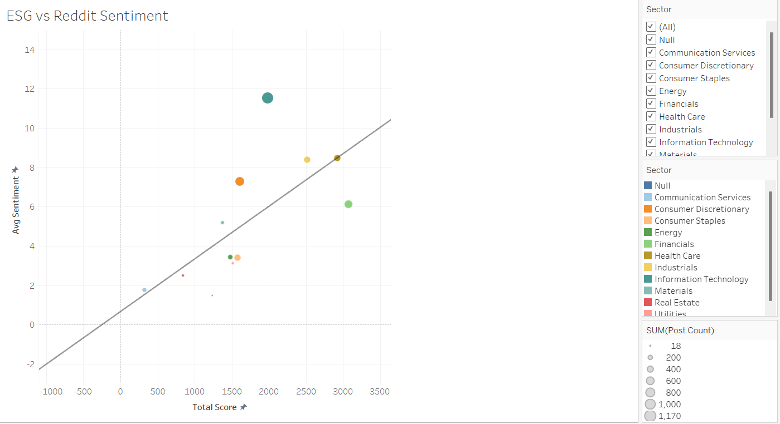
Figure 1: Scatter plot illustrating the relationship between total ESG scores and average public sentiment across firms. The dispersion highlights instances of CSR–sentiment alignment and misalignment, underscoring the complexity of stakeholder perception.

5.1.2 Pillar-Level ESG Comparisons
Pillar-level visualisations demonstrate notable variation across Environmental, Social, and Governance dimensions. Certain firms display strong performance in one pillar while underperforming in others, suggesting that aggregated ESG scores may mask underlying CSR imbalances. These differences are particularly pronounced across sectors.
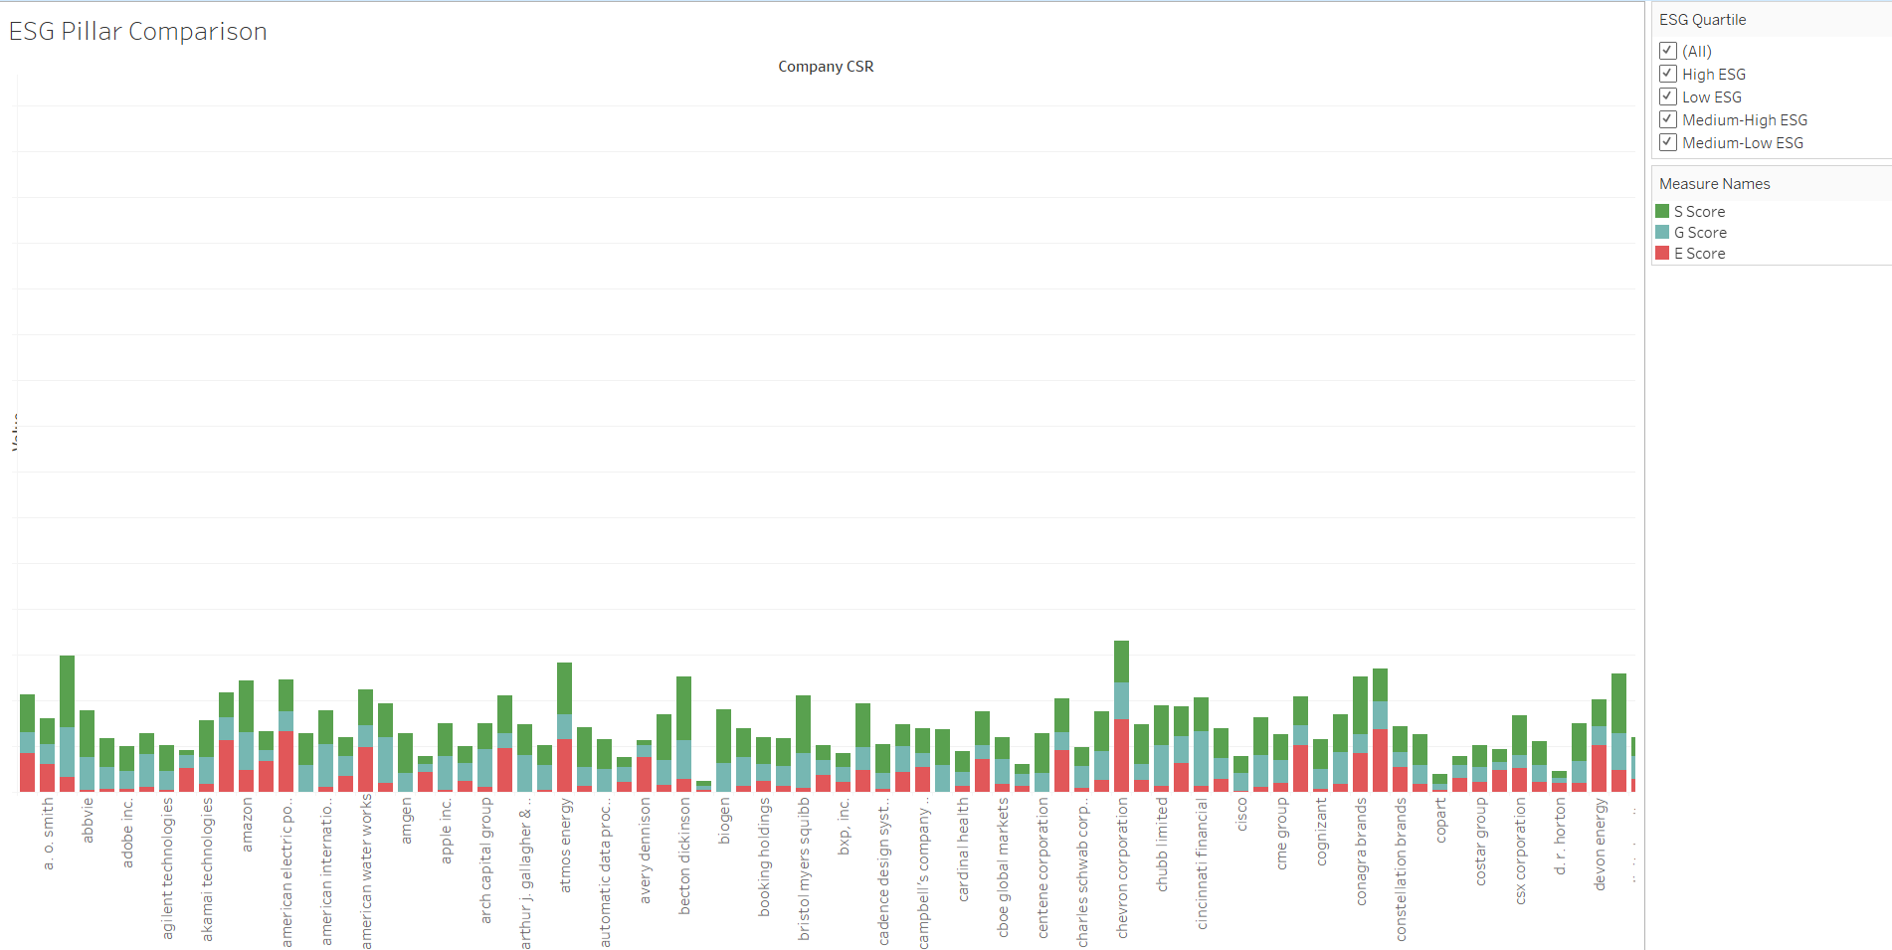
Figure 2: Comparison of Environmental, Social, and Governance pillar scores across firms, highlighting internal imbalances within CSR performance.

5.1.3 Sentiment Intensity Across ESG Quartiles
Although higher ESG quartiles exhibit slightly more positive median sentiment, the presence of negative sentiment across all quartiles suggests that stakeholder perception is influenced by factors beyond formal CSR disclosures.
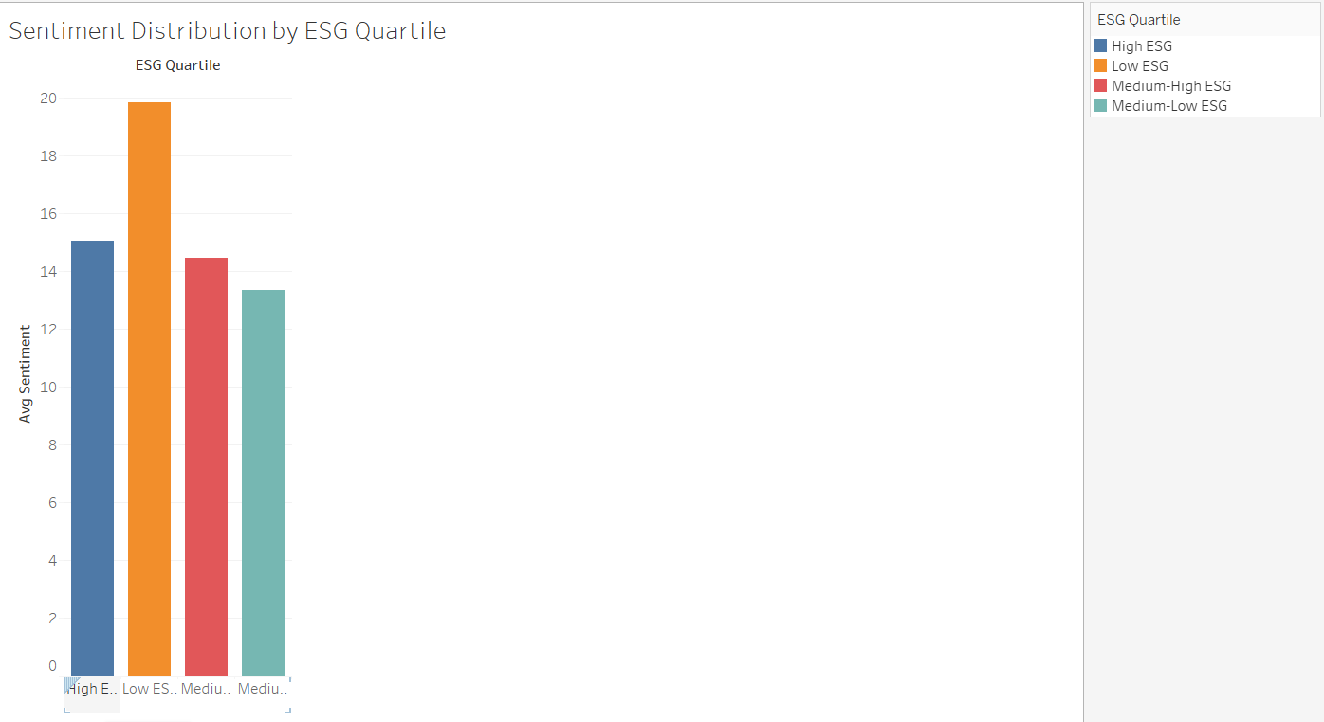
Figure 3: Distribution of public sentiment across ESG quartiles, illustrating substantial overlap and indicating that ESG performance alone does not determine public perception.

5.1.4 CSR-Sentiment Alignment Patterns
The binary alignment indicator reveals that a substantial proportion of firms are classified as misaligned, even among those with above-median ESG scores. This supports the project’s core argument that CSR communication effectiveness varies significantly and cannot be inferred solely from disclosure quality.
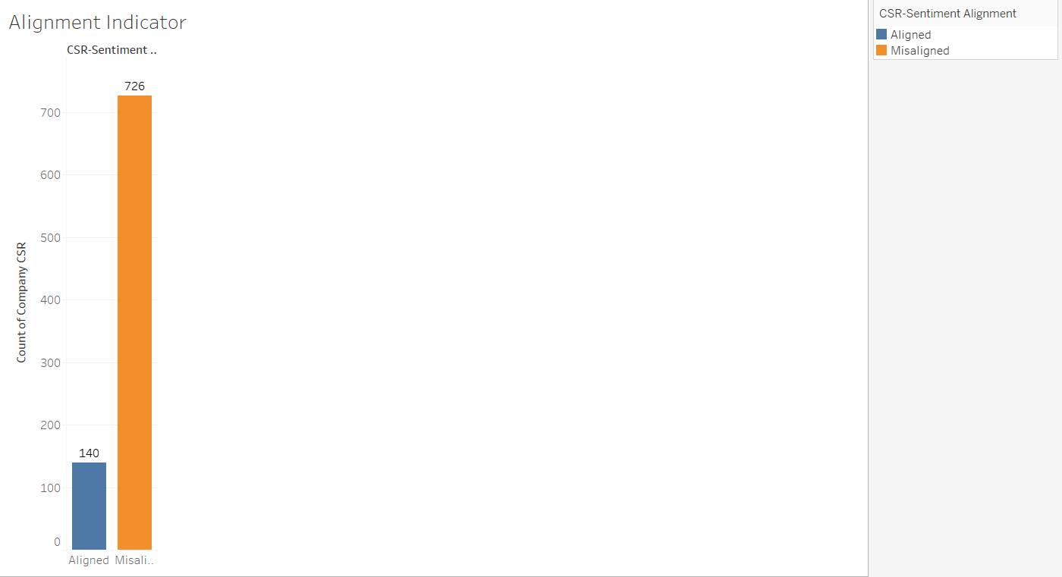
Figure 4: Distribution of aligned and misaligned firms based on relative ESG and sentiment thresholds, demonstrating the prevalence of CSR–sentiment misalignment.

5.1.5 Sector-Level Misalignment
Sector heatmaps reveal systematic clustering of misalignment in certain industries, suggesting structural communication challenges. Conversely, other sectors demonstrate more consistent alignment, potentially reflecting mature CSR engagement strategies.
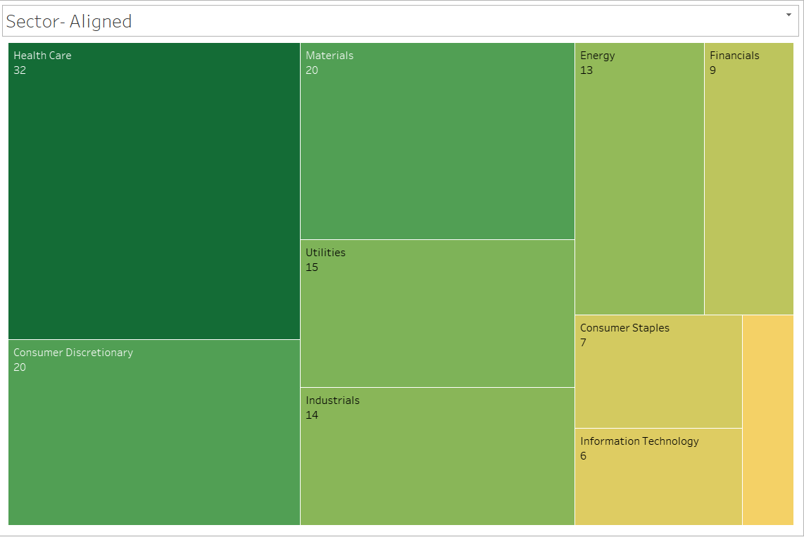
Figure 5: Aligned Sectors

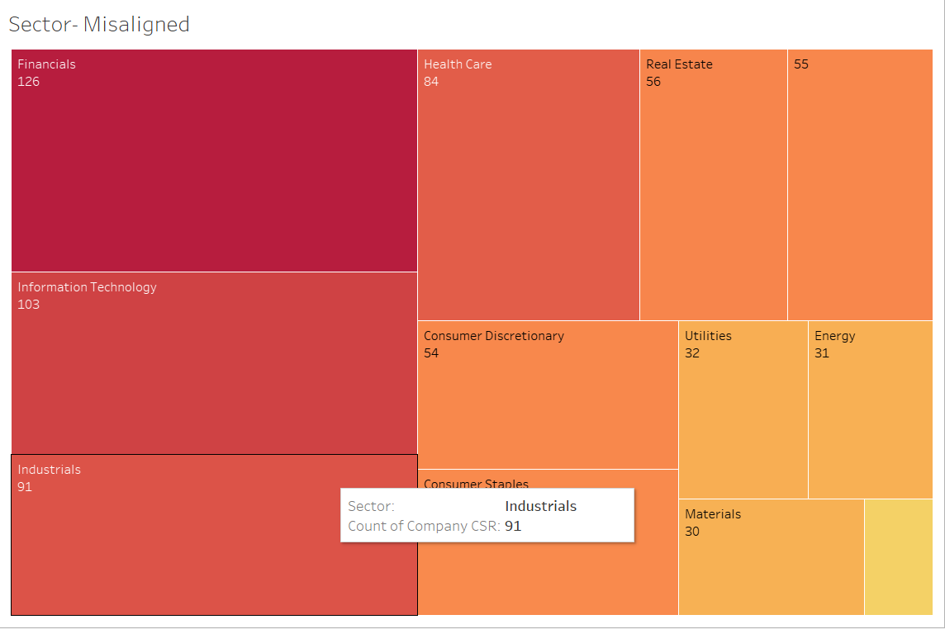
Figure 6: Misaligned Sectors

5.2 Model Results
This section presents the results of the statistical and machine learning models applied to assess the relationship between public sentiment and CSR performance. The objective of these models is exploratory rather than predictive, providing empirical support for patterns observed in the dashboard.

5.2.1 Regression Results
Ordinary Least Squares (OLS) regression analysis using a squared sentiment transformation reveals a statistically significant but weak relationship between sentiment intensity and total ESG scores. The negative coefficient suggests that extreme sentiment—particularly strong negative sentiment—is associated with lower ESG performance.
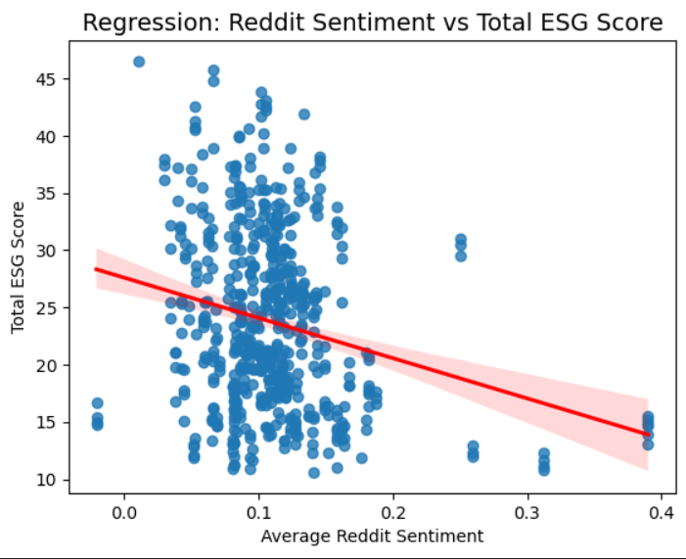
Figure 7: OLS regression illustrating the non-linear relationship between squared sentiment and total ESG score, indicating statistically significant but limited explanatory power.

5.2.2 Classification Model Results: ESG Performance
A logistic regression classifier predicting high versus low ESG performance achieved accuracy marginally above random classification. Balanced precision and recall across classes indicate limited discriminative power when relying solely on sentiment-derived features.
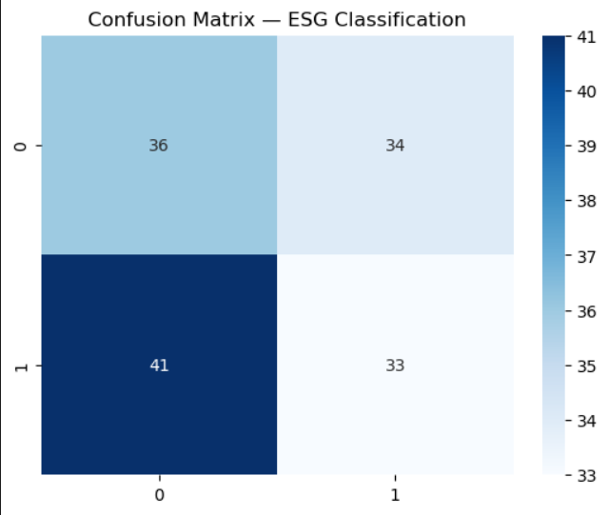
Figure 8: Confusion matrix for logistic regression predicting high versus low ESG performance, demonstrating modest classification accuracy.

5.2.3 Classification Model Results: CSR-Sentiment Alignment
A second logistic regression model predicting CSR–sentiment alignment achieved slightly higher accuracy and demonstrated strong recall for aligned firms. This suggests the model is effective at identifying alignment cases, though less effective at detecting misalignment.
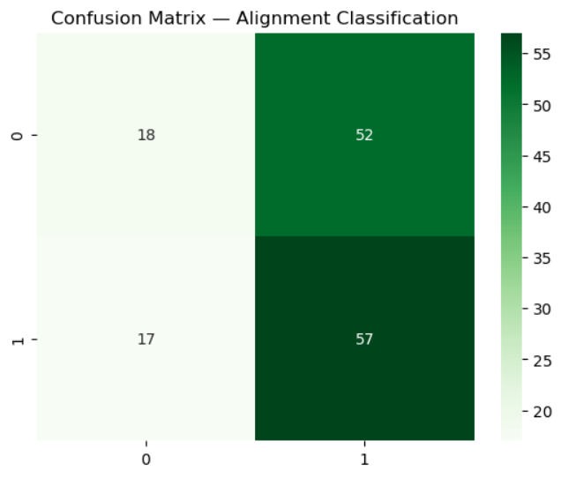
Figure 9:Confusion matrix for logistic regression predicting CSR–sentiment alignment, highlighting high recall for aligned firms.

5.3 Artefact Evaluation.
This chapter evaluates the effectiveness of the proposed Tableau-based dashboard in addressing the study’s aim. The evaluation focused on three key criteria: dashboard usability, interpretability of analytical outputs, and alignment with user needs.

5.3.1 Dashboard Usability
In terms of usability, the dashboards demonstrated a high level of accessibility and intuitive design. The structured layout, consistent visual hierarchy, and use of interactive elements-such as global filters for sector and ESG quartiles-allow users to navigate the analysis efficiently without requiring advanced technical expertise. The dashboard follows a logical analytical flow, guiding users from high-level overview visualizations to more detailed views which reduces cognitive load and supports exploratory analysis. These design choices make the artefact suitable for both academic and practitioner audiences.

5.3.2 Interpretability.
Interpretability was identified as a core strength of the dashboard. Visualizations such as the ESG vs Sentiment scatter plot enable rapid identification of alignment and misalignment patterns across firms. The introduction of a binary alignment indicator further simplifies complex multidimensional relationships into an accessible analytical construct. Additionally, pillar-level ESG comparisons and sector-based heatmaps enhance interpretive depth by revealing structural differences across CSR dimensions and industries. These features ensure transparency in the analytical logic and allow users to relate visual patterns directly to underlying data metrics.

5.3.3 Alignment with User Needs.
The dashboard also aligns well with identified user needs. For academic users, it provides a scalable framework for investigating CSR-sentiment relationships across a large dataset, complementing statistical and machine learning analyses. For practitioners, the artefact functions as a diagnostic decision-support tool, highlighting discrepancies between corporate disclosures and public perception that may require strategic intervention.
Overall, the evaluation confirms that the artefact successfully translates complex analytics into meaningful insights. While predictive accuracy is not its primary focus, the dashboard’s usability, interpretability, and strategic relevance make it an effective tool for evaluating CSR communication alignment. These findings support the conclusion that the artefact meets the study’s objectives and provides a strong foundation for further research and practical application.

5.4 Model and Analytical Evaluation
This section evaluates the statistical and machine learning models employed in the study, focusing on regression diagnostics and classification performance metrics. The objective is not solely to maximize predictive accuracy, but to assess whether the models provide meaningful empirical evidence regarding the relationship between CSR disclosures and public sentiment.

5.4.1 Regression Diagnostics
An Ordinary Least Squares (OLS) regression was used to examine the relationship between public sentiment and overall ESG performance, with a squared sentiment transformation applied to address skewness and potential non-linearity. The model explains approximately 5.1% of the variance in ESG scores. While this indicates a relatively weak explanatory power, the model is statistically significant overall (F-statistic = 30.84, p < 0.001), suggesting that sentiment contains non-random information relevant to CSR outcomes.
The coefficient for the squared sentiment term is negative and highlight significant ($β$ = -96.72, p < 0.001), indicating a non-linear relationship whereby extreme sentiment-particularly negative sentiment intensity-is associated with lower ESG scores. This supports the polarised sentiment may reflect perceived misalignment between CSR disclosures and public perception.
Diagnostic statistics indicate moderate departures from ideal OLS assumptions. The Omnibus and Jarque Bera tests suggest residual non-normality, while the Durbin-Watson statistic (0.67) points to positive autocorrelation. These issues are acknowledged limitations but are not uncommon in social media-derived data and do not invalidate the directional interpretation of results.

5.4.2 Classification Metrics
Two supervised classifications were evaluated using logistic regression, selected due to its interpretability and suitability for binary outcome prediction in exploratory analytical contexts. Model A employed logistic regression to predict high versus low ESG performance based on transformed sentiment features. The model achieved an accuracy of 47.9% and an ROC-AUC of 0.53, indicating performance only marginally above random classification. Precision ad recall values were relatively balanced across both classes but remained modest, reflecting the inherent difficulty of inferring ESG performance from public sentiment alone.
Model B, was designed to predict CSR-sentiment alignment, operationalized as a binary outcome derived from relative ESG and sentiment thresholds. This model demonstrated slightly improved performance, achieving an accuracy of 52.1% and an ROC-AUC of 0.53. A notable strength of this model was its high recall for the “Aligned” class (0.77), indicating that the model was effective at identifying forms whose CSR disclosures were broadly consistent with public sentiment. However, this improvement came at the expense of lower recall for misaligned cases, highlighting a trade-off between sensitivity and specificity.
Overall, the classification results suggest that logistic regression models based solely on sentiment-derived features have limited predictive power when applied to complex constructs such as ESG performance and CSR alignment. Nevertheless, the models provide meaningful probabilistic signals that complement the regression analysis and visual diagnostics. These findings reinforce the study’s methodological choice to prioritise exploratory analytics and dashboard-based interpretability over purely predictive optimisation, aligning with the study’s aim of supporting CSR assessment.

5.5 Evaluation of Overall Approach
This study adopted an integrative analytical approach combining statistical modelling, machine learning classification, and interactive data visualization to examine the alignment between corporate social responsibility (CSR) disclosures and public sentiment. A key strength of this approach lies in its interdisciplinary design, which bridges quantitative analysis and visual analytics to support both empirical investigation and practical interpretation. By integrating structured ESG data with unstructured sentiment data, the study advances beyond siloed CSR analyses and provides a more holistic view of corporate–stakeholder alignment.
Another notable strength is the emphasis on interpretability rather than predictive optimization. The use of linear regression and logistic regression models enabled transparent evaluation of relationships between sentiment and ESG performance, while the Tableau dashboard translated these findings into accessible insights for non-technical stakeholders. This aligns with the project’s applied objectives, particularly the development of a decision-support artefact for CSR communication assessment.
However, several limitations must be acknowledged. The models exhibited relatively low explanatory and predictive power, indicating that sentiment alone is insufficient to robustly explain ESG outcomes. This reflects the multifaceted nature of CSR performance, which is influenced by regulatory, financial, and organizational factors not captured in the current dataset. Additionally, sentiment measures derived from social media are inherently noisy and may be subject to selection bias, platform-specific discourse dynamics, and temporal volatility.
In terms of generalizability, the findings are most applicable to large, publicly visible firms operating in data-rich environments. The reliance on ESG scores and publicly available sentiment data limits the applicability of the approach to smaller firms or those in regions with less developed disclosure practices. Methodologically, the cross-sectional design restricts causal inference, and future research could benefit from longitudinal analysis to capture dynamic alignment trends.
Overall, despite these constraints, the approach is methodologically sound and well-suited to the project’s exploratory aims, providing a scalable foundation for future refinement and extension.

Chapter 6: Conclusion

6.1 Summary of the Project
This project set out to evaluate the alignment between corporate social responsibility (CSR) disclosures and public perception by integrating structured ESG performance data with unstructured sentiment data derived from online public discourse. Motivated by growing concerns regarding the credibility and effectiveness of corporate sustainability communications, the study adopted a data-driven approach to assess whether firms’ reported CSR commitments resonate with stakeholder sentiment.
Methodologically, the project employed a combination of exploratory data analysis, regression modelling, classification techniques, and interactive visual analytics. Sentiment scores were derived and transformed to address distributional skewness, while ESG metrics were analyzed both independently and in relation to public sentiment. The final artefact—a Tableau-based analytical dashboard—was designed to translate complex analytical outputs into interpretable insights, enabling users to explore alignment patterns across firms, ESG dimensions, and industry sectors.

6.2 Summary of Results
The empirical analysis revealed a statistically significant but weak negative relationship between public sentiment and overall ESG scores, even after applying a square transformation to address skewness in sentiment data. The low R-squared values observed across regression models indicate that sentiment alone explains only a small proportion of variation in ESG performance, underscoring the multifactorial nature of CSR outcomes.
Classification results further supported this conclusion. Logistic regression–based models predicting ESG performance and CSR–sentiment alignment achieved accuracy levels only marginally above random classification. However, the alignment classification model demonstrated relatively high recall for aligned firms, suggesting that sentiment signals are particularly informative for identifying cases where corporate messaging resonates positively with public perception. Sector-level visualizations revealed systematic patterns of misalignment in certain industries, highlighting the contextual nature of CSR communication effectiveness.

6.3 Achievement of Aims and Objectives
The primary aim of assessing CSR–sentiment alignment using big data analytics was successfully achieved. The first objective—gathering and preprocessing CSR disclosure data and public opinion data—was met through the integration of ESG scores and sentiment metrics. The second objective, employing analytical and machine learning techniques to identify alignment patterns, was fulfilled through regression analysis, classification modelling, and diagnostic evaluation.
The third objective, designing a prototype dashboard reflecting alignment and misalignment, was fully realized through the development of an interactive Tableau dashboard incorporating scatter plots, alignment indicators, sector heatmaps, and comparative ESG visualizations. Finally, the project met its fourth objective by generating empirically grounded insights that inform recommendations for improving CSR communication strategies, particularly in sectors exhibiting persistent misalignment.

6.4 Extent to Which the Problem Was Addressed
The project effectively addressed the core problem of fragmented evaluation between CSR disclosures and public perception by proposing an integrated analytical framework. While the models did not achieve high predictive accuracy, the solution succeeded in revealing structural gaps between reported CSR performance and stakeholder sentiment. Importantly, the dashboard artefact provides a practical and scalable mechanism for ongoing monitoring of alignment, offering value beyond static analytical outputs.

6.5 Future Work
Future research could enhance this framework by incorporating additional data sources such as earnings calls, sustainability controversies, or employee reviews to enrich sentiment measures. Advanced modelling techniques, including ensemble learning and transformer-based sentiment models, may improve predictive performance. Finally, integrating real-time data pipelines would enable continuous dashboard updates, transforming the artefact into a dynamic CSR intelligence tool for strategic stakeholder management.

Bibliography

Appendices

Record of Meetings with Supervisor

9th September 2025: [12.00 – 12.30 p.m.] | Discussed Aims, Objectives and Target Audience of the project
23rd September 2025: [12.00 – 12.30 p.m.] | Discussed on methods with regard to collection of data from various sources
7th October 2025: [12.00 – 12.30 p.m.] | Sorting Issues with regards to data collection methods
14th October 2025: [12.00 – 12.30 p.m.] | Discussion on Notebook Structure
21st October 2025: [12.00 – 12.30 p.m.] | Discussion on Evaluation of Findings
25th November 2025: [12.00 – 12.30 p.m.] | Discussion on improved R² values using transformation techniques
9th December 2025: [12.00 – 12.30 p.m.] - In | Discussion on report structure and contents
16th December 2025: [12.00 – 12.30 p.m.] - In | Discussion on final artefact
5th January 2025: [12.00 – 12.30 p.m.] - In | Discussion on key mistakes and how to avoid them

Ethical Approval Form
Below is a link to the Ethical Approval form uploaded to Google Drive
Ethical Form

GitHub Repository Link
Below is a link to the GitHub repository which contains the notebooks used in the projects
GitHub Repository

References
Awa, H. O. et al. (2024) Stakeholders, stakeholder theory and Corporate Social Responsibility (CSR). International Journal of Corporate Social Responsibility. [Online] 9 (1).
Barbeito‐Caamaño, A. & Chalmeta, R. (2020) Using big data to evaluate corporate social responsibility and sustainable development practices. Corporate social-responsibility and environmental management. [Online] 27 (6), 2831–2848.
Borland, H. et al. (2018) Business Strategies for Sustainability. 1st edition. Helen Borland et al. (eds.). [Online]. United Kingdom: Routledge.
Bosi, M. K. et al. (2022) Sustainability Reporting through Environmental, Social, and Governance: A Bibliometric Review. Sustainability. [Online] 14 (19), 12071.
Cuesta-Valiño, P. et al. (2024) Guest editorial: Happiness and corporate social responsibility: the role of organizational culture and consumers in a sustainable economy. Management decision. [Online] 62 (2), 373–380.
Delmas, M. A. & Burbano, V. C. (2011) The Drivers of Greenwashing. California Management Review. [Online] 54 (1), 64–87.
Dilla, W. et al. (2016) Investor views, investment screen use, and socially responsible investment behavior. Sustainability accounting, management and policy journal (Print). [Online] 7 (2), 246–267.
Ioannou, I. & Serafeim, G. (2011) EXECUTIVE SUMMARY: THE POWER OF TRANSPARENCY. Business strategy review. [Online] 22 (3), 76–76.

Khan, M. et al. (2016) Corporate Sustainability: First Evidence on Materiality. The Accounting Review. [Online] 91 (6), 1697–1724.

Kolk, A. (2016) The social responsibility of international business: From ethics and the environment to CSR and sustainable development. Journal of world business: JWB. [Online] 51 (1), 23–34.
Mamo, Y. Z. & Anagnostopoulos, C. (2023) Stakeholders’ “voice” through social media: the case of corporate social responsibility in sport. International journal of sports marketing & sponsorship. [Online] 24 (5), 1002–1020.
Michelon, G. et al. (2015) CSR reporting practices and the quality of disclosure: An empirical analysis. Critical perspectives on accounting. [Online] 3359–78.
Saxton, G. D. et al. (2019) Do CSR Messages Resonate? Examining Public Reactions to Firms’ CSR Efforts on Social Media. Journal of business ethics. [Online] 155 (2), 359–377.
Ujjwal, D. et al. (2023) ‘Big Data Influence on The Corporate Social Responsibility: Benefits and Challenges’, in 2023 International Conference on Computational Intelligence, Communication Technology and Networking (CICTN). [Online]. 2023 Piscataway: IEEE. pp. 121–125.
Yu, E. P. et al. (2020) Greenwashing in environmental, social and governance disclosures. Research in international business and finance. [Online] 52.

